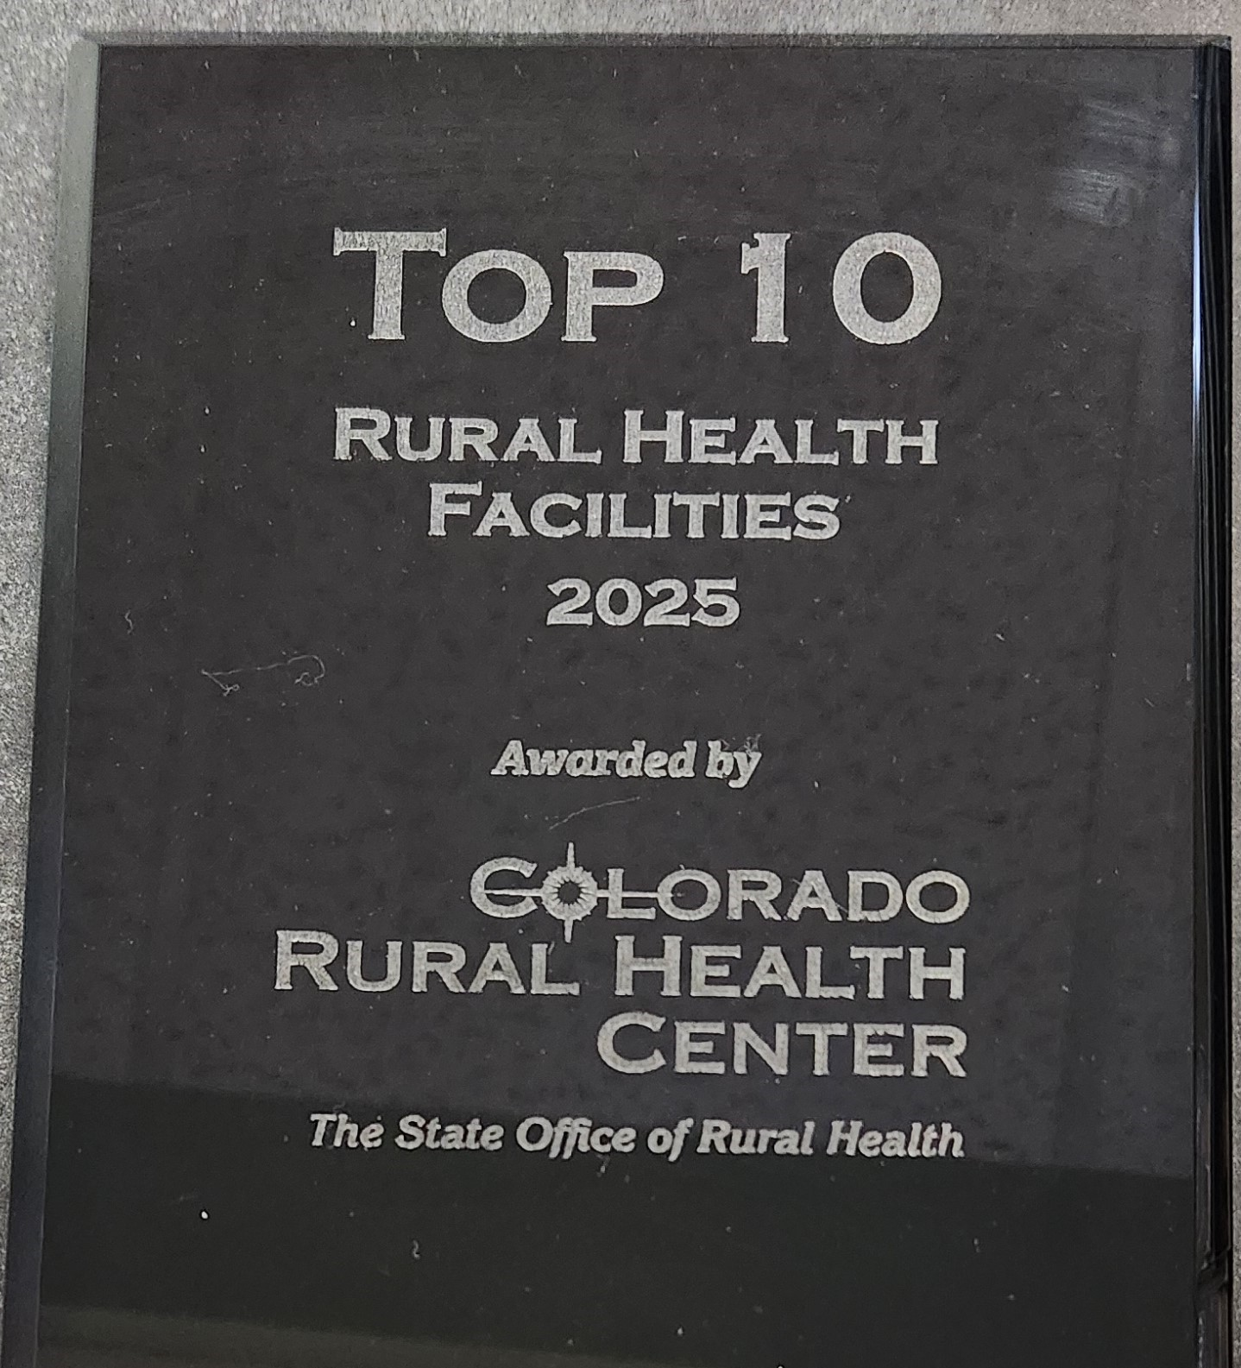 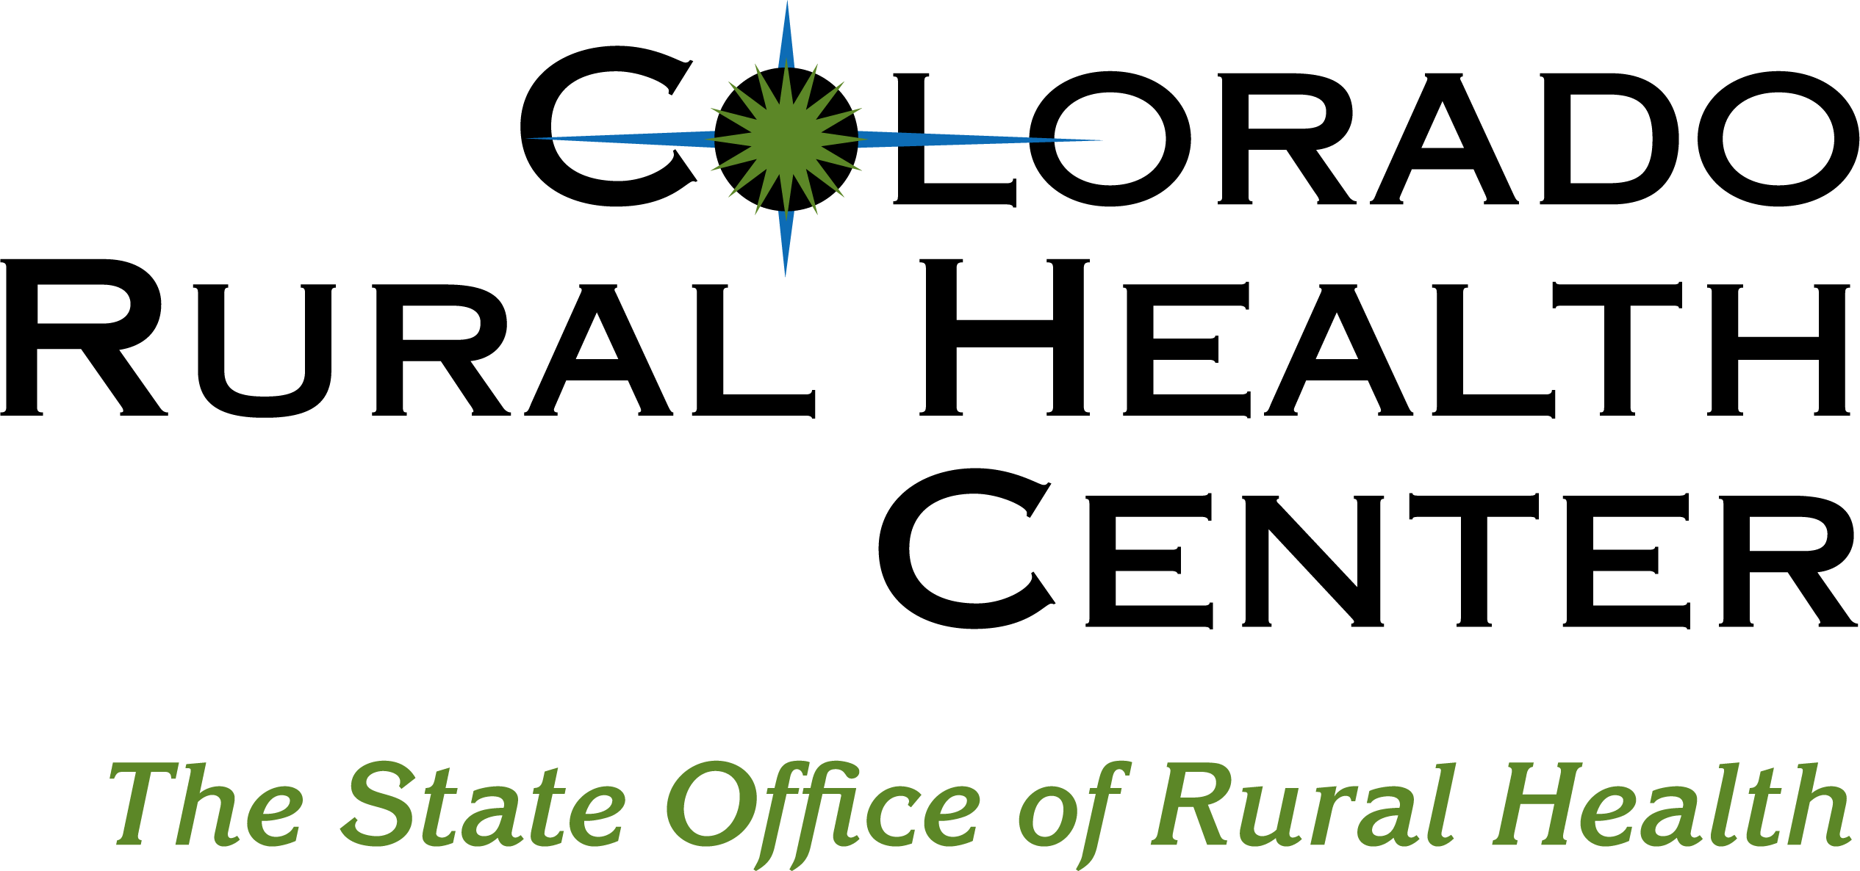

FOR IMMEDIATE RELEASE

Walsh Medical Clinic

719-324-5253

Walsh Medical Clinic Honored for Overall Performance by   
Colorado Rural Health Center

Walsh Colorado, March 26, 2025 – Walsh Medical Clinic announced today that the facility has been honored by the Colorado Rural Health Center (CRHC) as a Top 10 Rural Healthcare Facility for Overall Performance in rural Colorado. Presented during The Colorado Rural Healthcare Conference, the award recognizes participation in CRHC programs and reflects a commitment to quality, innovation, and service to the community.

Cathy Miller, Clinic Manager stated, “The Walsh Medical Clinic appreciates the Colorado Rural Health Center for everything they do for us. We are very honored to receive this award.”

The Top 10 Rural Healthcare Facility for Overall Performance Award recognizes 5 hospitals and 5 clinics for outstanding commitment to serving their communities. CRHC’s data team considered clinic participation in quality improvement activities, excellence in innovation, and a commitment to the health of local communities.

“Local clinics are the lifeblood of rural healthcare delivery systems. Often in conjunction with their local hospital rural clinics dutifully serve their communities and visitors alike to keep everyone healthy and thriving,” said CRHC CEO Michelle Mills. “We’re thrilled to introduce this new awards program and recognize the outstanding overall performance of the state’s top hospitals and clinics.”

The Walsh Medical Clinic has two providers, Mary Shy, FNP and Courtney Stuart, FNP. They are dedicated to serving our community with friendly faces and personal care. Service offerings include well care of adults and children, as well as management of chronic conditions and treatment of acute illnesses.

**Media Inquiries:**

Cathy Miller

Walsh Medical Clinic

Walshmedclinic@gmail.com

719-324-5253

About The Colorado Rural Health Center

The Colorado Rural Health Center was established in 1991 as Colorado's State Office of Rural Health. As a 501(c)(3) nonprofit corporation, CRHC serves dual roles as the State Office of Rural Health and the State Rural Health Association. The organization’s mission is to enhance healthcare services in the state by providing information, education, linkages, tools, and energy toward addressing rural health issues. CRHC’s vision is to improve healthcare services available in rural communities to ensure that all rural Coloradans have access to comprehensive, affordable, high quality healthcare. For more information visit [www.coruralhealth.org](http://www.coruralhealth.org/), call 303-832-7493, or call toll free 800-851-6782 from rural Colorado.